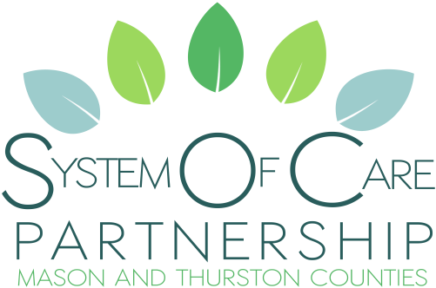
b
Vision: We are a community working together to strengthen sustainable resources for the individual behavioral health needs of children, youth and families.
Mission: Through respectful partnerships, families, systems and communities collaborate, influence and provide leadership to address challenges and barriers by promoting cohesive behavioral health services for children, youth and families.

Friday March 22nd from 10 am until Noon

Zoom Link for online participation: https://us02web.zoom.us/j/5857207072?omn=83572027649

Call In: 1-253-215-8782 Meeting ID: 585 720 7072

Youth Text Group

Join by sending a text to Monty at 360-229-3818.

Zoom Operator

Text 425-749-0050 or Email christmanbrandi@gmail.com

For anyone having trouble joining the meeting.

For anyone unable to access chat and prefers to share with the group through a Zoom operator.

AGENDA
Welcome (15)
- Zoom Tools/Information
- https://us02web.zoom.us/j/5857207072?omn=83572027649
- Introductions
- Reading of Vision & Mission
- Group Agreement
- Tri-lead Listening Statement
Today’s Goals (1)
- Discuss Actionable Items for Area of Focus
- Sharing School Resources
- Share Time
Area of Focus (page 3) (65)

- Discuss Actionable Items using Poll Everywhere
- Hub
- Matrix
- Telehealth
- State and Regional Data
- Social Media
- Questions/Comments
Sharing School Resources (20)
- School Districts/Educational Services District
- Questions/Comments
Share Time for All (15)
- Questions or comments about today’s goals/agenda.
- Information/Announcements
- New or Existing Program Updates
- Services/Resources
- Questions/Comments
Adjourn

Area of Focus

More mental health providers available to young people and their families regardless of income and health insurance. This would be a change in the system as well as services rendered.

Contacts for Questions, Comments or Concerns

Tri-lead Information

Jacque Ward, Co-Family Tri-lead
jacqueward72@gmail.com

Philip Compton, Co-Family Tri-lead
mrpbsc@gmail.com
360-972-1100

Spencer McQuilkin, Co-Youth Tri-lead
Nky71470@gmail.com

Alexandra Jacobson, Co-Youth Tri-lead
ajacobson824@gmail.com

Heidi Knadel, Co-System Tri-lead
Heidikn@ccsww.org
360-791-0785

Donna Kelly, Co-System Tri-lead
donna@obhadvocacy.org

Convener Contact Information

Donna Obermeyer
360-790-7505
familyalliancewashington@gmail.com
https://www.familyallianceformentalhealth.com/system-of-care-partnership.html

Story Group Resource and Technical Assistance

Carrie Moisey
360-346-0299
carriem@ccsww.org

